# Tangrams

Tangram is an ancient Chinese geometric puzzle. It uses a square cut into seven pieces, which can be arranged to create different figures.

Objective of the puzzle: to form a specific shape using all seven pieces, which may not overlap.



* Print the pattern on thick paper or paper card so you can use it again!
* Cut out the pieces.
* Use the puzzle pieces to recreate the patterns below

# Colour and make your own Tangram

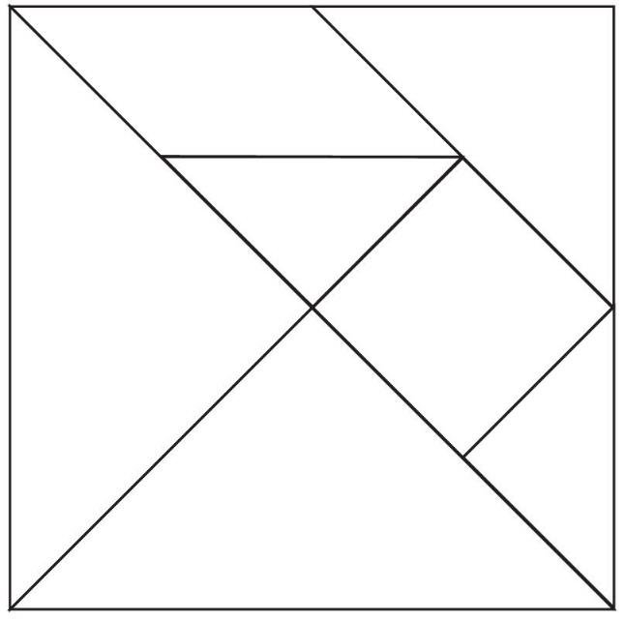

* Print the pattern on thick paper or paper card so you can use it again!
* Cut out the pieces.
* Use the puzzle pieces to recreate the shadowed patterns below

# How quickly can you recreate these patterns?

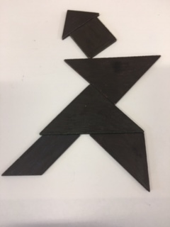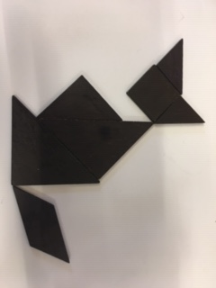

**Person**

**Fox**

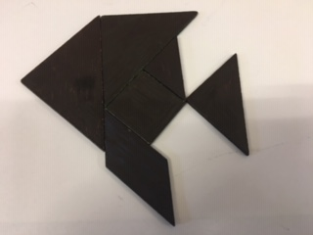 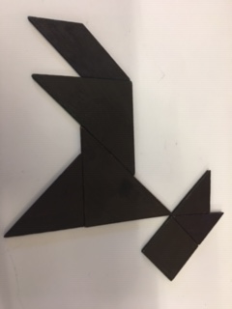

**Horse**

**Fish**

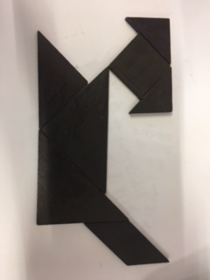 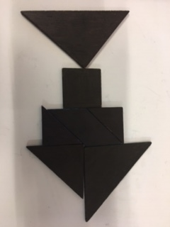

**Fish 2**

**Dog**

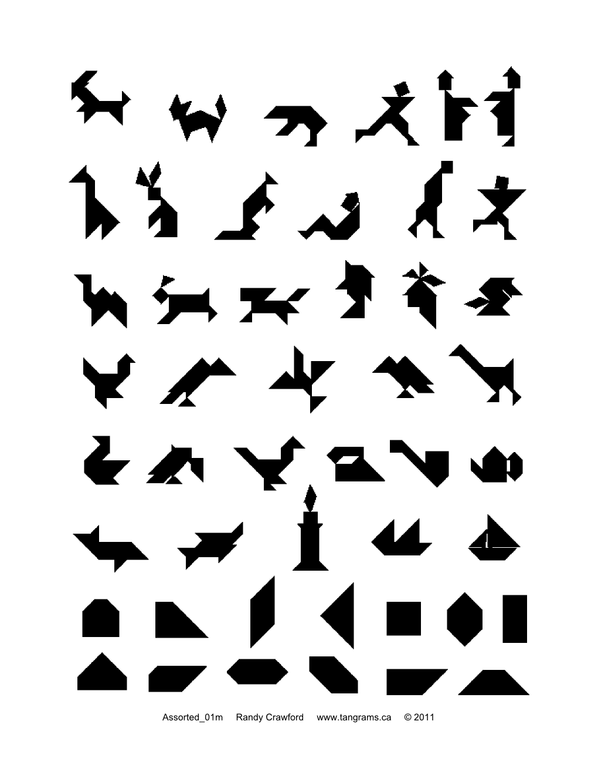

From <<https://www.interactive-maths.com/tangrams-ggb.html>>

# PAIRS

One person closes their eyes or uses a blindfold and tries to recreate the patterns below by following the instructions of their partner.

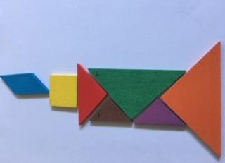 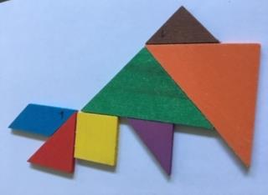

**Candle**

**Rabbit**

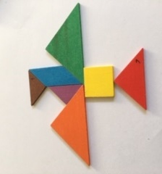 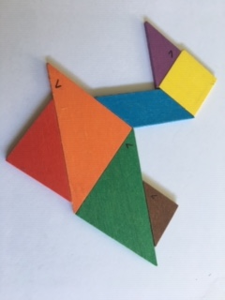

**Eagle**

**Swan**

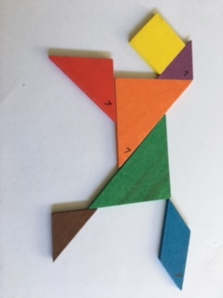 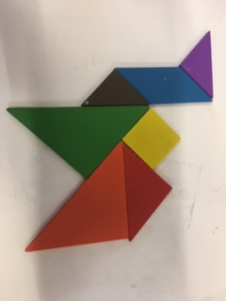

**Horse**

**Camel**