**Matchstick puzzles**

Matchstick puzzles are derived from a time when candles and gas lighting meant that almost everyone carried a small box of matches with them. These puzzles are designed for you to complete equations, move matchsticks to solve brain teasers or involve counting squares to solve the riddles. Websites have also been included which have the answers to the problems.

You can use the following items instead of matchsticks:

Sticks

Toothpicks

Pencils/pens

Crayons

Cutlery

Here are a few matchstick puzzles to get you started….. You will find the solutions at the following websites

1. **Move One Matchstick**

Can you make these two equations true by moving just **ONE** matchstick?

Note: It can be done in at least three ways.

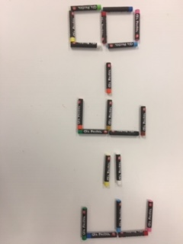 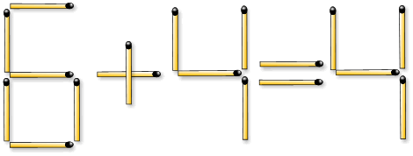

<https://gpuzzles.com/brain-questions/matchsticks/> <http://www.learning-tree.org.uk/stickpuzzles/stick_puzzles.htm>

1. **Turning the donkey**

**MOVE** 1 matchstick/pencil to turn the donkey.

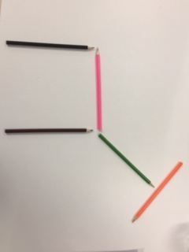 <http://www.learning-tree.org.uk/stickpuzzles/stick_puzzles.htm>

1. Equation Riddle

Can you **ADD** one matchstick to make the equation below true?

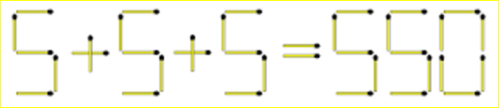

<https://gpuzzles.com/brain-questions/matchsticks/>

**Have fun!**