Hacky Sack
Did You Know?
In 1997, Ted Martin set an individual hackysack record with 63,326 consecutive kicks.

Hacky sack is the name given to a brand of footbag popular in the 1970’s.
Hacky sack is fun to practice alone or to play with friends. The aim of the game is to keep the sack off the ground for as long as possible. Hacky sacks are a great way to kill time, have fun, and increase your balance, agility and foot control skills.
Basic skills video
https://www.youtube.com/watch?v=_MfoxBPT-YY
How to play hacky sack in a group
https://www.youtube.com/watch?v=guQyAWwIYnw

- Gather your friends in a circle about four to five feet across.
- Serve the hacky sack to any player by gently tossing it about waist high.
- Keep the hacky sack in the air using any part of the body but your arms or hands.
(Use your thigh, heel, inside of the foot, and forehead to keep it aloft)
- If a player lets the hacky sack hit the ground – or touches it with a hand or arm – the game must be restarted.
( Only the server can use their hands - and only when they serve the hackysack)
Here are several easy ways to make a hacky sack out of household materials or basic craft supplies.

https://www.wikihow.com/Make-a-Hacky-Sack

Sewing a sock
Cut an old sock. Find a pair of old socks without holes or worn areas. Cut off the tip of each one, about 3–4 inches (7.5–10 cm) from the toes.[
Sew one piece most of the way closed. Thread a needle with a long piece of strong thread. Pull it through both sides of the sock, near the hole. Continue sewing by moving the needle back through the sock again in the other direction. Repeat this back-and-forth movement until the sock is sewn mostly shut. Leave a gap for stuffing the sock.
Tip: the closer together your thread lines, the less your hacky sack will leak stuffing.

Pour in rice or other material. Stick a funnel in the hole, or a rolled-up paper cone. Fill the sock with stuffing material. Uncooked rice or lentils are cheap and large enough that they won't fall out much. Plastic pellets or steel pellets from a hobby store will give more control, and feel more like commercial hacky sacks.
Tip: sand or birdseed tends to leak out of this style of hacky sack.

Sew the second sock over the first. For extra protection, pull the second piece of sock over the first. Sew it shut just as you did the first one. Align this sock so the two holes are on opposite ends, reducing the chance of material leaking out.

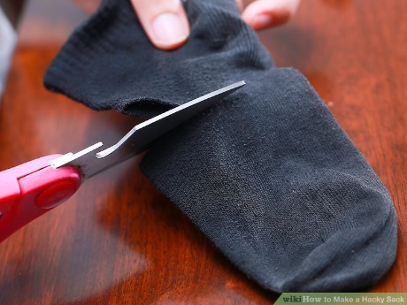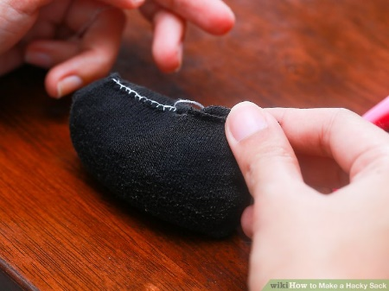

Using Balloons
Use this to make temporary hacky sacks. Balloon sacks are super quick and easy to make. They won't last as long as other hacky sacks, but a replacement will only cost you a few minutes and a dip in the change jar.

Stick a funnel into the neck of a balloon. Get a round, uninflated balloon. Stretch the opening wide and push in the end of a funnel.
If you don't have a funnel, make one out of paper

Fill with sand or other material. Sand-filled sacks are easy to "stall" on the foot, useful for beginners or people learning tricks. Birdseed, dried beans or lentils, uncooked rice, or small beads are other fine alternatives. Fill the balloon to the neck.
Cut off the neck. Remove any dangling rubber, to make the sack spherical.
If using fine sand, you may want to tie a knot instead. This helps stop sand leaking out, but the knot will make the ball bumpy.

Cover with several more balloons. Pull another balloon over the exposed hole and around the whole ball. Cut off the neck. Repeat with at least two more balloons, covering each previous hole. For a stronger sack, use up to ten balloons.
For decoration, you can cut small holes in the balloons so the different colour shows through.

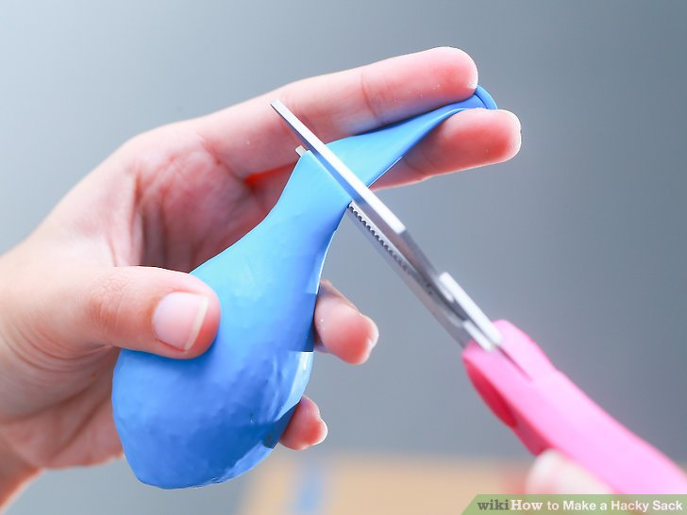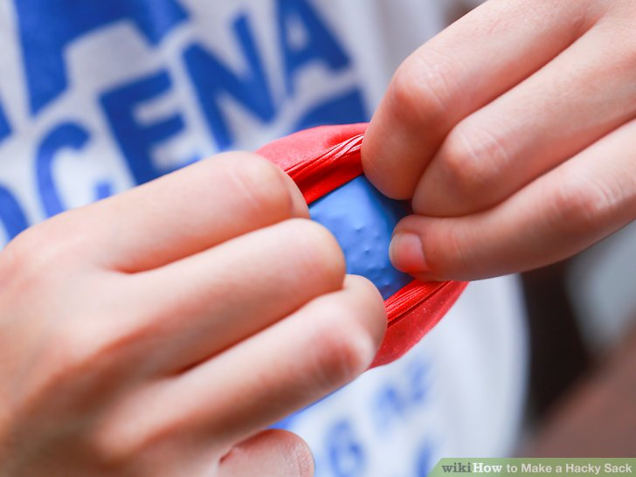

Other ways to make hacky sacks is to crochet or knit a hacky sack.

